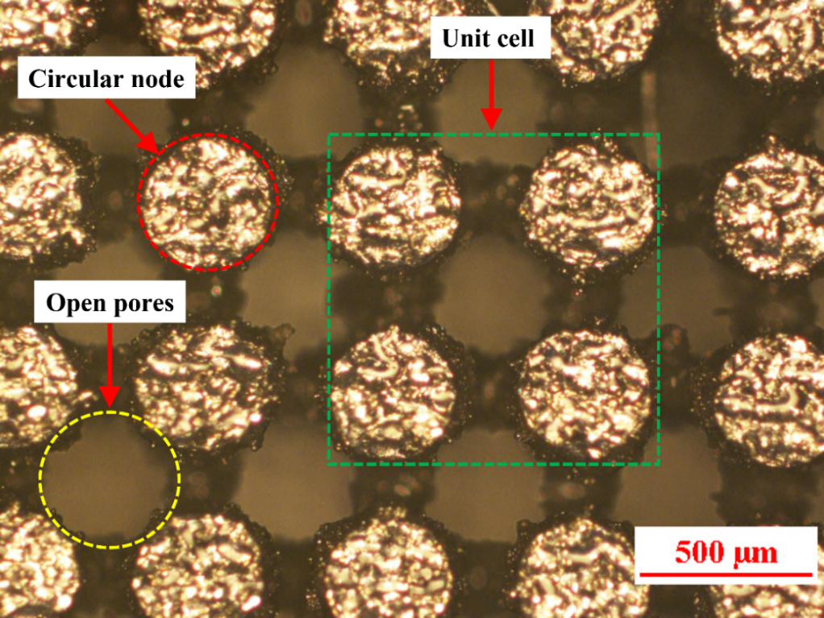
Run | Input parameters |  |  | Output responses
 | Peak current (A) | Pulse-on time  (µs) | Duty factor  (%) | Tool wear rate | Volume removal rate | Average deviation
 |  |  |  |  |  | Hole top | Hole bottom
1. | 4 | 50 | 56 | -83.46 | 0.56 | 231.56 | 213.91
2. | 4 | 75 | 64 | -112.87 | 0.69 | 217.78 | 199.06
3. | 4 | 100 | 72 | 408.11 | 0.51 | 230.15 | 212.08
4. | 4 | 150 | 80 | -268.75 | 0.52 | 270.55 | 213.04
5. | 6 | 50 | 64 | 75.95 | 0.47 | 205.29 | 143.39
6. | 6 | 75 | 56 | 68.64 | 0.65 | 225.36 | 172.72
7. | 6 | 100 | 80 | 154.33 | 0.54 | 280.53 | 130.03
8. | 6 | 150 | 72 | 180.31 | 0.55 | 219.68 | 53.86
9. | 8 | 50 | 72 | 91.02 | 0.40 | 240.17 | 96.38
10. | 8 | 75 | 80 | 282.03 | 0.62 | 260.48 | 122.89
11 | 8 | 100 | 56 | 96 | 0.97 | 240.25 | 213.69
12. | 8 | 150 | 64 | 246.99 | 1.48 | 213.86 | 216.67
13. | 10 | 50 | 80 | 489.4 | 0.62 | 238.61 | 122.43
14. | 10 | 75 | 72 | 90.69 | 0.77 | 251.62 | 155.43
15. | 10 | 100 | 64 | 418.52 | 0.84 | 227.14 | 204.55
16. | 10 | 150 | 56 | 490.57 | 0.98 | 231.89 | 26.84

